Problem 1ai:
Confusion matrix:

0 1 2 3 <-- assigned to cluster
5 137 1 0 | cp
2 7 43 60 | im
25 0 0 0 | om
48 3 0 1 | pp

Cluster Entropies:
0: 1.3496
1: 0.4185
2: 0.1565
3: 0.1207

Classes cp and im are easily separable although im is divided between between classes 2 and 3. Classes om and pp are both captured in class 0. One can see from the entropies that cluster 0 is much more confused than the others and clusters 2 and 3 have the most information of any cluster.

Problem 1aii:
Confusion matrix:

0 1 2 <-- assigned to cluster
5 137 1 | cp
2 9 101 | im
25 0 0 | om
48 3 1 | pp

Cluster Entropies:
0: 1.3496
1: 0.4694
2: 0.1576

Classes cp and im are again easily separable. And again om is hidden within pp. From the clustering of these two problems, I would guess that in most attributes cp and im are distinct but om is a smaller cluster hidden within pp. And again the entropy shows that cluster 0 is not very informative but cluster 2 is very informative.

Problem 1aiii:
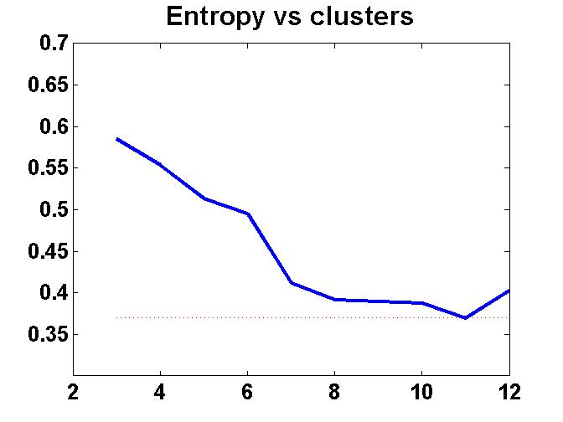
The sum of squared errors decreases as the number of clusters increases. It does not decrease monotonically as evidenced by the uptick at 12 clusters.

Problem 1aiv:
The SSE was 0.3695 at 11 clusters. The purity for most of the clusters is near 100% with the big exception being cluster 0 which encompasses both the om and pp classes.

Problem 1bi:
Three clusters
Confusion matrix:

0 1 2 <-- assigned to cluster
143 0 0 | cp
20 2 90 | im
19 6 0 | om
51 0 1 | pp

Cluster Entropies:
Cluster Entropies:
0: 1.5109
1: 0.8113
2: 0.0873

Four clusters
Confusion matrix:

0 1 2 3 <-- assigned to cluster
141 0 0 2 | cp
10 2 85 15 | im
19 6 0 0 | om
51 0 1 0 | pp

Cluster Entropies:
0: 1.4083
1: 0.8113
2: 0.0914
3: 0.5226

This clustering is different than before. Before, cp and im were separable from the other two classes, which were combined into a single class. In this clustering, only im is separable and the other three classes are lumped together.

Problem 1bii:
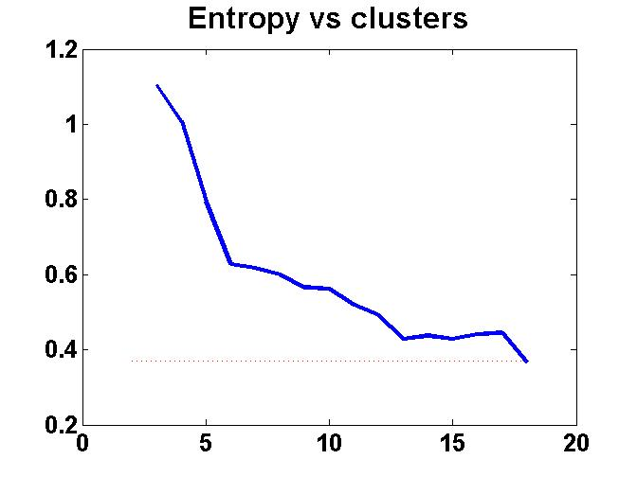
Eighteen clusters are required before the total weighted entropy falls below 0.37. Half of the clusters have 0 entropy(100% pure) and another 4 have entropies below 0.5.

Problem 1biii:
Farthest-first seems to like to group the majority of points into the first cluster. It has difficulty in deviating from this pitfall. Since farthest first selects the k-farthest points from each other as centers, I think tight, closely packed data would present a problem to this algorithm, especially if the initially chosen point is near the center of all the true clusters.

Problem 2a:
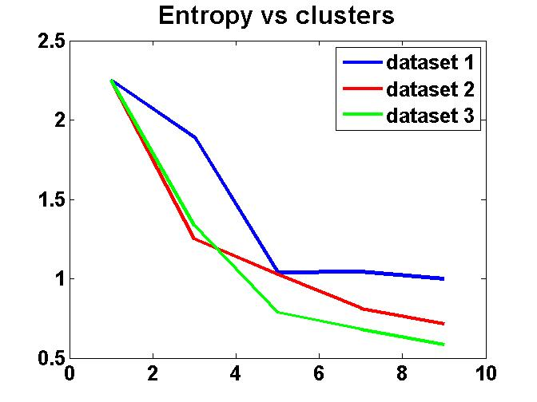

The entropy decreases as we increase the clusters. It decreases more quickly with each successive dataset as well. Each successive dataset has less noise so this makes sense since noise causes problems with clustering.

Problem 2b:
These datasets are noisy. We could try sampling the data to get rid of the noise. We could also try manually setting the initial point to be the center of one of the clusters. However, a hierarchical algorithm like complete-link would work best here considering the presence of noise.

Problem 3:
Simple k-means seems to work better than FarthestFirst in these cases. FarthestFirst seems overly susceptible to noise and from overlapping clusters. K-means, while not perfect, seems to perform better in general. Also, it might be that FarthestFirst has a problem with higher dimensional space since it uses a distance metric to define the k clusters and it might incorrectly place those cluster centers. And since it is using maximal min-distance, it probably tends towards globular clusters, like complete-link. If the data isn’t globular, then FarthestFirst will have problems.

DBSCAN would probably work well for the second problem as the data is well separated and the classes have similar densities. For the E. coli dataset DBSCAN would probably fail since there are overlapping clusters of differing densities.

